CDF/DOC/TRACKING/PUBLIC/6287
Draft v1
Jan.25, 2003

Characteristics of Prototype Silicon Sensors for Run2b (II)

N. Bacchetta¹, G. Bolla⁴, D. Bortoletto⁴, A. Canepa⁴, B. Flaugher¹, I. Gorelov³, K. Hara⁵,
M. Hoeferkamp³, D. Pellet², S. Seidel³, Y. Takei⁵, P. Watje³

¹Fermilab, Batavia, Illinois, USA
²University of California at Davis, Davis, California, USA
³University of New Mexico, Albuquerque, New Mexico, USA
⁴Purdue University, West Lafayette, Indiana, USA
⁶University of Tsukuba, Tsukuba, Ibaraki, Japan

Abstract
Five prototype silicon sensors fabricated were irradiated with neutrons up to $1\text{.}4×{\text{10}}^{\text{14}}$n/cm², as a part of the sensor quality assurance program for Run2b silicon detector. This note describes the characteristics of irradiated sensors. We comment on charge-up susceptibility of the new sensors which use wafers in <100> direction.

1. Introduction

The prototype sensors are AC coupled and single-sided, which are designed to have a lifetime until the end of Run2b. Due to the intense radiation level, the full depletion voltage will, after type inversion, increase up to about 200V (100V) at 15 fb⁻¹ and to 380V (200V) at 30 fb⁻¹ for the L0 (L1) sensors located 2 cm (3 cm) from the collision point. These estimates include a safety margin of 1.5 in the radiation fluence, and the corresponding 1 MeV equivalent neutron fluences are $1\text{.}4×{\text{10}}^{\text{14}}$n/cm². This note describes the electrical performance of five sensors irradiated with neutrons. The evaluations were performed at three universities, Tsukuba, Purdue and New Mexico. An extensive summary for pre-irradiation sensors is reported in CDF note 6286. fabricated by Hamamatsu have been extensively studied on performance against radiation such as for LHC application. Our consensus is that HPK sensors are superior in all aspects and should be operational at least up to 2-3 x10¹⁴ n/cm². In order to verify this, we have irradiated 5 axial prototypes with neutrons at MNRC Irradiation Facility at UC Davis on September 27, 2002. The expected total doses were $1\text{.}4×{\text{10}}^{\text{14}}$n/cm² for 3 sensors and $0\text{.}7×{\text{10}}^{\text{14}}$ n/cm² for 2 sensors. The two sensors irradiated to $0\text{.}7×{\text{10}}^{\text{14}}$ n/cm² were characterized at Tsukuba, which are reported here.

2. Performance of Neutron-Irradiated Sensors

The Hamamatsu sensors have been extensively studied on performance against radiation such as for LHC application. Our consensus is that HPK sensors are superior in all aspects and should be operational at least up to 2-3 x10¹⁴ n/cm². In order to verify this, we have irradiated 5 axial prototypes with neutrons at MNRC Irradiation Facility at UC Davis on September 27, 2002. The expected total doses were $1\text{.}4×{\text{10}}^{\text{14}}$n/cm² for 3 sensors and $0\text{.}7×{\text{10}}^{\text{14}}$ n/cm² for 2 sensors. The two sensors irradiated to $0\text{.}7×{\text{10}}^{\text{14}}$ n/cm² were characterized at Tsukuba, which are reported here.
The sensors were cooled to extract characteristics which are not affected by the radiation induced large leakage current. Both sensors were glued on PC frames where fan-out readout traces are made. The back-plane, bias-ring, 10 consecutive AC pads and 10 consecutive DC pads were wire-bonded to these readout traces to allow us for testing described here. The sensor was placed in an environment chamber throughout the measurements. The measurements were carried out also in dry nitrogen environment, the results being essentially identical to those obtained in normal air.

6.1 Total Leakage Current

Fig. 11a shows I-V curves measured at temperatures ranging –30 to –10ºC. First, we note that there is no breakdown up to 1000V we measured.
The measurements were carried out 45 days after irradiation. It is known that the leakage current of irradiated sensors will decrease (annealing) right after irradiation and later increase (anti-annealing). The damage constant α is expressed by $α={φ⋅ΔI}/V$, where $φ$ is the neutron fluence, $ΔI$is the increase in the total leakage current measured at full depletion voltage, and $V$is the volume of the sensor. Because of the features of annealing and temperature dependence of the leakage current, α is usually calculated after the initial annealing is completed and at 20ºC.
Systematic measurements of the initial annealing are available such as from Rose Collaboration, which is shown in Fig. 11b. At room temperatures, the current decreases substantially within a month, approaching to an asymptotic damage constant of $3×{\text{10}}^{−\text{17}}$ A/cm.
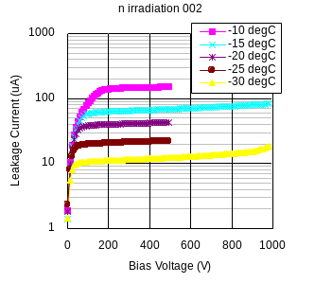
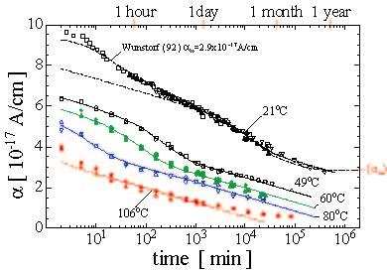
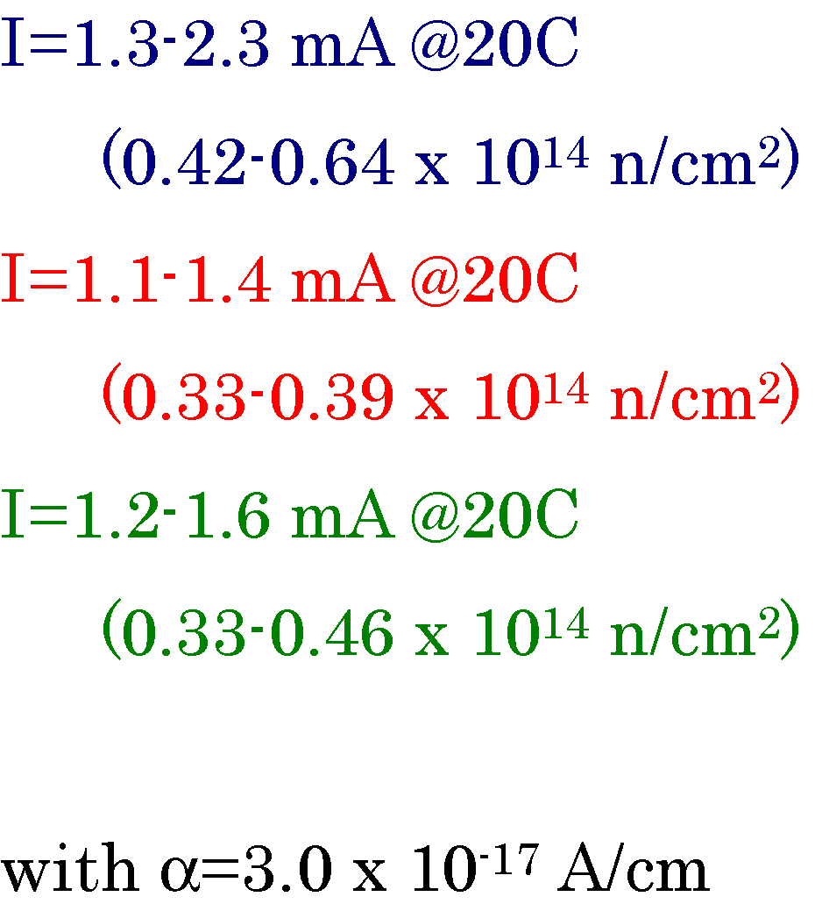
Fig. 11c plots the leakage current at full depletion as a function of the temperature. Extrapolation to 20ºC is made using
Fig. 11a I-V curves of irradiated sensor.

Fig. 11b Damage constant as a function of time, showing initial annealing (Rose Collab)
Fig. 11c Leakage current at full depletion and its extrapolation to 20ºC. The extrapolation is done for three sets of data described in the text (marks at 20ºC are slightly shifted so that difference can be seen).
$$I(T)∝T^{n}\text{exp}\left(−E_{g}/2k_{B}T\right)$$
where$E_{g}$=1.12eV and n is taken to be 2. The results are barely sensitive to a choice of n=1.5. There are three sets of data plotted in the figure: one set (green) for 001 Sensor and two sets (blue and red) for 002 measured on 45 days and 51 days after irradiation. The range of leakage current thus obtained is 1.1 to 2.3 mA at 20ºC. The neutron fluence calculated from these values is 0.33-0.64${\text{10}}^{\text{14}}$/cm². The present result prefers somewhat smaller neutron fluence but is in reasonable agreement with the anticipated fluence of 0.7${\text{10}}^{\text{14}}$/cm².

6.2 Full Depletion Voltage

Figure 12a shows C-V curves measured at temperatures at between –25 and –10ºC. The LCR frequency was set to 100 Hz. The data are shown for the two sensors. The full depletion voltage obtainable from these curves apparently depends on temperature, which should not be physical. The frequency was chosen so that the C-V curve at lower bias is significant. The frequency dependence is studied at –10 and –20 ºC (Fig. 12b). It seems C-V curves measured at higher frequencies (400Hz and 1 kHz) result smaller “full depletion voltage”. The determination is, however, not straightforward, since we can not perform reliable fits for such data.
Fig. 12a C-V curves of n-irradiated sample. (Left) 001 Sensor and (Right) 002 Sensor. The data for 002 Sensor are taken 51 days after irradiation and the data on 45 days after are shown for comparison.
The evolution of the full depletion voltage is calculated (see Fig. 12c) using the parameters given by ROSE Collaboration. In the present calculation, we assume that the initial full depletion voltage is 150 V and the sensor is irradiated to equivalent neutron fluence of 0.7${\text{10}}^{\text{14}}$/cm². Appendix summarizes the equations and the parameters we used, where an expectation for 1.4${\text{10}}^{\text{14}}$/cm² is also given.
Fig. 12b Frequency dependence of bulk capacitance measured at –10 and –20ºC.
We expect that the full depletion voltage be around 40 V. The C-V measurement should be affected largely by leakage current, and we consider the measurement at lower temperatures represents the intrinsic depletion voltage, which is around 30-40V and is in good agreement with the expectation.

1min
1day
1mon
1yr
Fig. 12c Evolution of full depletion voltage since completion of irradiation. Parameters are taken from ROSE Collaboration. Initial full depletion voltage 150V, and neutron fluence 0.7
/cm².

6.3 Interstrip Resistance

The interstrip resistance is one of the key parameters to evaluate the radiation effect on silicon detectors. The oxide layer between strips accumulates positive charges created due to radiation, which degrades the interstrip resistance.
Figure 13 shows bias dependence of the resistance. The data are shown for different temperatures (Sensor 001) and for five sampled strips (Sensor 002) measured at –25ºC. The strip leakage current was almost constant to 85-90nA during these measurements. The resistance was greater than 40 GΩ (see Fig. 6) before irradiation. The resistance can be more than 1G Ω if the bias is set at 250V (50V) at –10ºC (–25ºC). Although the bias voltage 250V is larger than the full depletion voltage, where we naively expect that the strips are isolated, the required voltage is small enough and manageable.
Fig. 13 Interstrip resistance as a function of bias voltage. (Left) Temperature dependence measured for 001 Sensor. (Right) channel dependence measured for 002 Sensor.

6.4 Interstrip Capacitance

The interstrip capacitance of irradiated sensors was measured for sampled strips. Figure 14a shows the bias dependence and LCR frequency dependence measured for a particular set of neighboring strips. The measurements at 1 MHz are affected largely by leakage current, and the measured capacitances are substantially large at higher temperatures. From the frequency dependence, 1MHz is no high enough especially at higher temperatures. It seems all the data approach to 3 pF at higher frequency, the asymptotic value being consistent with that of non-irradiated sensors.
Fig. 14a Interstrip capacitance of irradiated sensor. (Left) Bias dependence measured at LCR frequency of 1MHz, (Right) LCR frequency dependence measured at Vb=300V.
Comparison of different strip pairs is shown in Fig. 14b for the two sensors. The capacitance was measured at –25ºC and for 1 MHz LCR frequency. The p+ strips are in the ohmic contact side after the bulk is inverted to p type. In this case we would expect that the strips are not well isolated unless the bulk is fully depleted. Then, the interstrip capacitance should decrease rapidly around the voltage cross the full depletion voltage. Although it is not very clear from the present data, the decrease is moderate and it requires a voltage of >200V to reach the asymptotic value. This can be explained qualitatively by the positive charges trapped in the oxide layer. The positive charges attract electrons, which depletes partially the p bulk in the interstrip region, achieving partial isolation even at small bias (Cint decreases moderately). Also, the electric field in the interstrip region is disturbed by these extra charges, resulting the isolation is not complete even above the full depletion voltage.
Fig. 14b Interstrip capacitance for sampled strips of (Left) Sensor 001 and (Right) Sensor 002. The LCR frequency is 1MHz and temperature is –25ºC.

3. Long-term stability test

The stability of leakage current is tested for in total eight sensors (4 axial and 4 stereo sensors) for a longer term. The bas voltage is kept at. 500 V and the whole setup is placed in an environment chamber at 20ºC. The leakage current data are taken typically once per day (the measurement is still on going). In addition to this, the durability of AC oxide is tested: 30 AC pads per sensor are wire bonded to an external voltage of +100V while the bias-ring is set to the ground level. It turns out the leakage current increases substantially when this external 100V is applied because of micro-discharge underneath the extended Al electrodes. Therefore, we decided to turn off this voltage for 1 hr prior to the leakage current measurement. The leakage current since Dec 4 when this decision was made is almost stable.
Out of eight sensors, one axial sensor (A23) showed breakdown at the AC oxide, indicating a creation of punch-through, on the 2nd day. Note again that axial sensors had been tested only at 100V prior. Other seven sensors are good so far.
Fig. 8a Long-term stability test of leakage current. The temperature is 20ºC and the bias is 500V. Note the change in the measurement procedure (see text) after 2002/12/05.

for stereo sensor S010

4. Effects of Charge-up
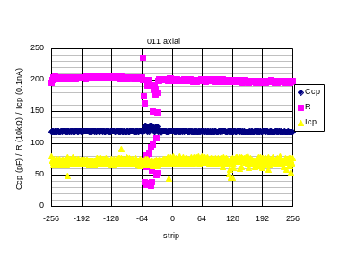
Fig.10a Example AC scan plot for a sensor with charge-up.
In an early stage of testing, we recognized that the sensors are easier to charge up compared to ISL/L00 sensors. This tendency was observed at Tsukuba and Purdue. Figure 10a is an example of such data obtained by Tsukuba. In this case, typically 30-40 central strips showed smaller resistances (R in the figure). Also some non-uniformity is seen for the coupling capacitors (Ccp) in the same region. From the location and spread, Tsukuba group suspected that the vacuum tweezers used to pick up the sensor was causing the trouble. After eliminating use of tweezers, this effect turned to be hard to appear.
The charge-up mechanism can be explained that a thin p-type layer, an inversion layer, is created on the surface of n-type bulk by external static charges. This deteriorates the electrical isolation between strips, which was actually identified from strip isolation test as well. This type inversion is easier to occur for <100> than for <111> because the positive charge trapped at the Si-SiO₂ interface and fixed oxide charge in SiO₂ layer are about one order abundant for <111>. This explains qualitatively why we did not see charge-up for ISL/L00 sensors, which employ <111> wafers. It is important to note that HPK is checking the isolation for every strip. This insures that the isolation degradation occurred during handling. Actually all the sensors have recovered from charge-up when they are placed back in the envelope which is used by HPK at sensor delivery. But it is also the observation that the charge-up can remain if the sensor is just kept on the test stage.
The inversion layer could remain for a long time if there is no route for the charges to move. In our detector application, though, there are a couple of routes possible: (1) Al electrodes are connected to ASICs, (2) Signal currents are created by particles passing through, and (3) Positive ions are accumulated in oxide layer due to radiation. The positive ions (3) attract electrons at the oxide-silicon boundary, thus removing the inversion layer. Therefore, the inversion layer, even if it presents at beginning, should not deteriorate the detector performance after the detector is in operation for a certain period.
We have carried out several tests such as to investigate time constants for the inversion layer to disappear. The tests include studying the effect of wire-bonding simulating the connection to ASICs, of epoxy applied on the surface for hybrid gluing, and of UV illumination. Preliminary observations we have are:
- Inversion layers seem to diminish quickly if the sensors are wire-bonded.
- If the sensors are not wire-bonded, the surface charge could remain at least for days.
- Removal of inversion layer is accelerated if the sensor is illuminated with UV.
- Epoxy on the surface helps to remove the charge, but too much epoxy degrades the surface isolation, which in turn makes the sensor easily affected by external conditions.

The above are preliminary since the study is not complete. We planed to carry out more systematic studies, but failed to do because we have not succeeded to reproduce charge-up sensors. Comparing the easiness of charge-up we encountered at earlier time, the sensors, three months after delivery, must have changed the susceptibility. One of such changes could be that oxide layers have accumulated positive charges, which prevents the sensor from charge-up.

8. Conclusions

We have evaluated the electrical performance of axial and stereo prototypes fabricated for the SVX2b detector. The prototypes fulfill our specifications. The leakage current is small and most sensors show no breakdown up to 1000V, our specification being 500V. Number of dead channels is quite small. We fully understood the faulty strips reported by the manufacturer. In addition, we found some new faulty strips. New punch-throughs are due to a parameter miss-understanding at testing of axial sensors. We have found no new punch-through for stereo sensors. We recognized a limitation in detecting readout implant opens by HPK: We found five new readout implant opens out of in total 36 tested sensors (out of more than 18k strips).
Two sensors irradiated with neutrons are characterized. The measurement results of I-V, C-V, interstrip capacitance and resistance, and polysilicon resistance are consistent with characteristics previously known. The expected full depletion voltage after 0.7x10¹⁴ n/cm² is about 40 V, our data being consistent with this expectation. Because of bulk type inversion and large leakage current, we require a bias of typically 200V, much higher than the full depletion voltage, to achieve good isolation between strips and to minimize the interstrip capacitance.
The mechanical precisions have been measured, which are satisfactory for our application.
Appendix. Equations used to calculate evolution of full depletion voltage

The full depletion voltage of silicon sensor with thickness of d is given by

$$V_{\text{FD}}=\frac{\left|N_{\text{eff}}\right|{\text{ed}}^{2}}{2ε}$$
under planer diode assumption. Here permittivity of silicon is $ε=\text{11}\text{.}9×8\text{.}\text{85}×{\text{10}}^{−\text{14}}$F/cm. The same equation is used to calculate the initial impurity density$N_{\text{eff}0}$using the initial full depletion voltage (150 V).
The initial n type impurity density decreases with radiation (and time) since new levels of displacement damages induced by radiation act as effectively p type:

$$N_{\text{eff}}=N_{\text{eff}0}−N_{\text{damage}}(φ,t,T)$$
The radiation effects can be classified into three types.
$$N_{\text{damage}}(φ,t,T)=N_{c}(φ)+N_{a}(φ,t,T)+N_{Y}(φ,t,T)$$

The first effect is stable damage, representing increase of donor type impurities and creation of acceptor type impurities, which is expressed by the following equation:
$$N_{c}(φ)=N_{c0}\left(1−\text{exp}(−cφ)\right)+g_{c}φ$$
The fraction ${N_{c0}}/{N_{c}}$refers to “incompleteness” in donor removal.
The second effect is short-term annealing after irradiation.

$$N_{a}(φ,t,T)=g_{a}φ\text{exp}\left(−k_{a0}t\text{exp}\left({−E_{\text{aa}}}/{k_{B}}T\right)\right)$$
where the model assumes activation energy$E_{\text{aa}}$and time constant $k_{a0}$.
The last effect is long-term reverse annealing:

$$N_{Y}(φ,t,T)=g_{Y}φ\left(1−\frac{1}{1+k_{Y\text{10}}t\text{exp}(−{E_{\text{aY}}}/{k_{B}}T)}\right)$$
The parameters used in the calculation are listed below.
1min
1day
1mon
1yr
Similar to Fig. 11e, but for neutron fluence 1.4
/cm²
$$N_{c0}=0\text{.}\text{65}N_{\text{eff}0}$$
$c=1\text{.}1×{\text{10}}^{−\text{13}}$cm²
$g_{c}=1\text{.}\text{49}×{\text{10}}^{−2}$cm⁻¹
$g_{a}=1\text{.}\text{81}×{\text{10}}^{−2}$ cm⁻¹
$g_{Y}=5\text{.}\text{16}×{\text{10}}^{−2}$ cm⁻¹
$k_{a0}=2\text{.}4×{\text{10}}^{\text{13}}$ s⁻¹
$k_{Y\text{10}}=1\text{.}5×{\text{10}}^{\text{15}}$ s⁻¹
$E_{\text{aa}}=1\text{.}\text{09}$ eV
$E_{\text{aY}}=1\text{.}\text{33}$ eV

Four consecutive sensors showed similar effects before Tsukuba stopped using tweezers. Recently, in order to carry out a study described here, we are back to use the same tweezers to intentionally charge a sensor up but failed.
See, for example, S. M. Sze, “Semiconductor Devices”: John Wiley & Sons 1985.

